**LAB2**

Answer#1

For loop:

#include <stdio.h>

int main() {

int num, i;

printf("Enter any Number:\t");

scanf("%d",&num);

for(i=1; i <= 2*num; i=i+2)

printf("%d ",i);

return 0;

}

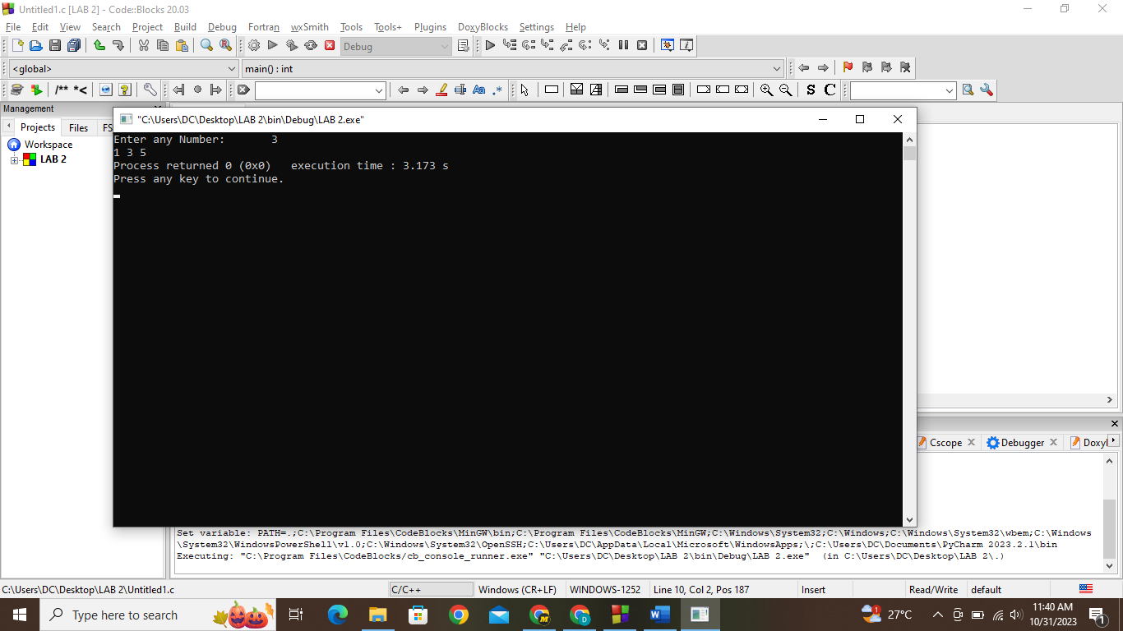

While loop**:**

#include <stdio.h>

int main() {

int num, i=1;

printf("Enter any Number:\t");

scanf("%d",&num);

while(i <= 2*num){

printf("%d ",i);

i=i+2;

}

return 0;

}

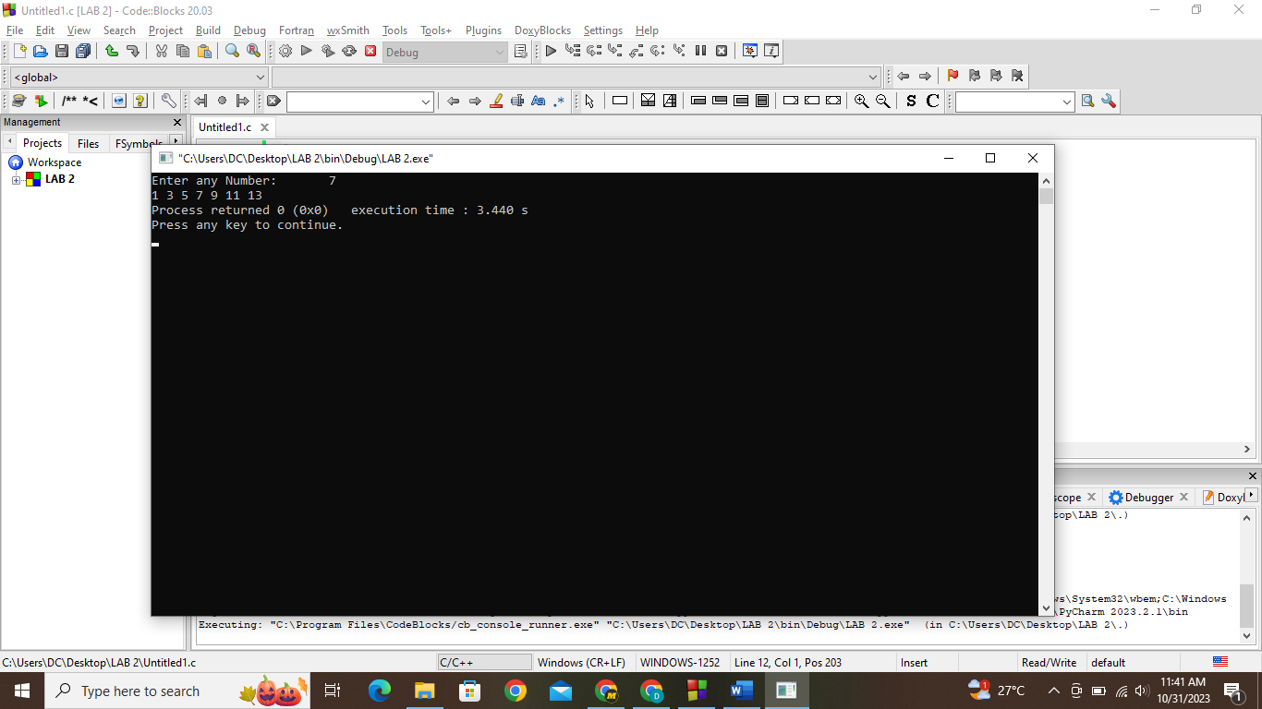

Do-While loop**:**

#include <stdio.h>

int main() {

int num, i=1;

printf("Enter any Number:\t");

scanf("%d",&num);

do{

printf("%d ",i);

i=i+2;

}while(i <= 2*num);

return 0;

}

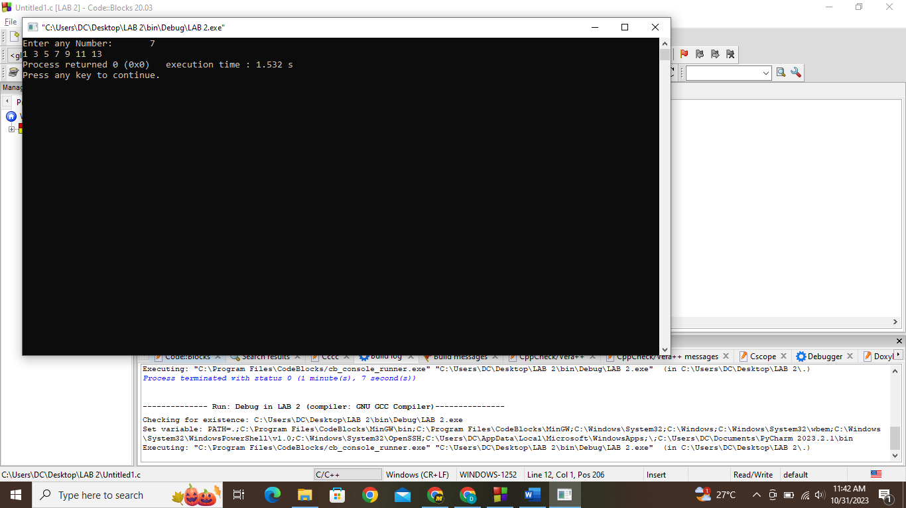

**Answer#2**

#include <stdio.h>

int main() {

int rows, i, j, space;

printf("Enter number of rows:\n");

scanf("%d", &rows);

for (i = 1; i <= rows; i++) {

for (space = 1; space <= rows - i; space++) {

printf(" ");

}

for (j = 1; j <= i; j++) {

printf("* ");

}

printf("\n");

}

return 0;

}

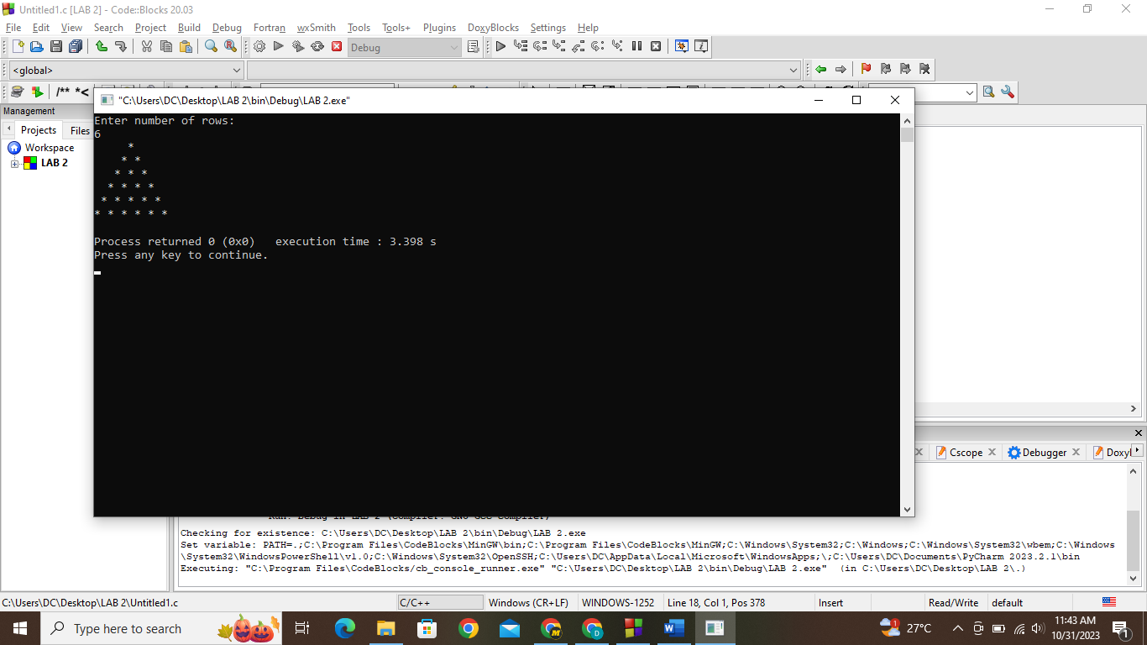

**Answer#3**

#include <stdio.h>

int main(){

char s1[] = "default", s2[] = "default";

printf("Enter the first string: ");

scanf("%s", &s1);

printf("Enter the second string: ");

scanf("%s", &s2);

int i;

for(i = 0; s1[i]==s2[i] && s1[i]!='\0'; i++);

printf("%d", s1[i] - s2[i]);

return 0;

}

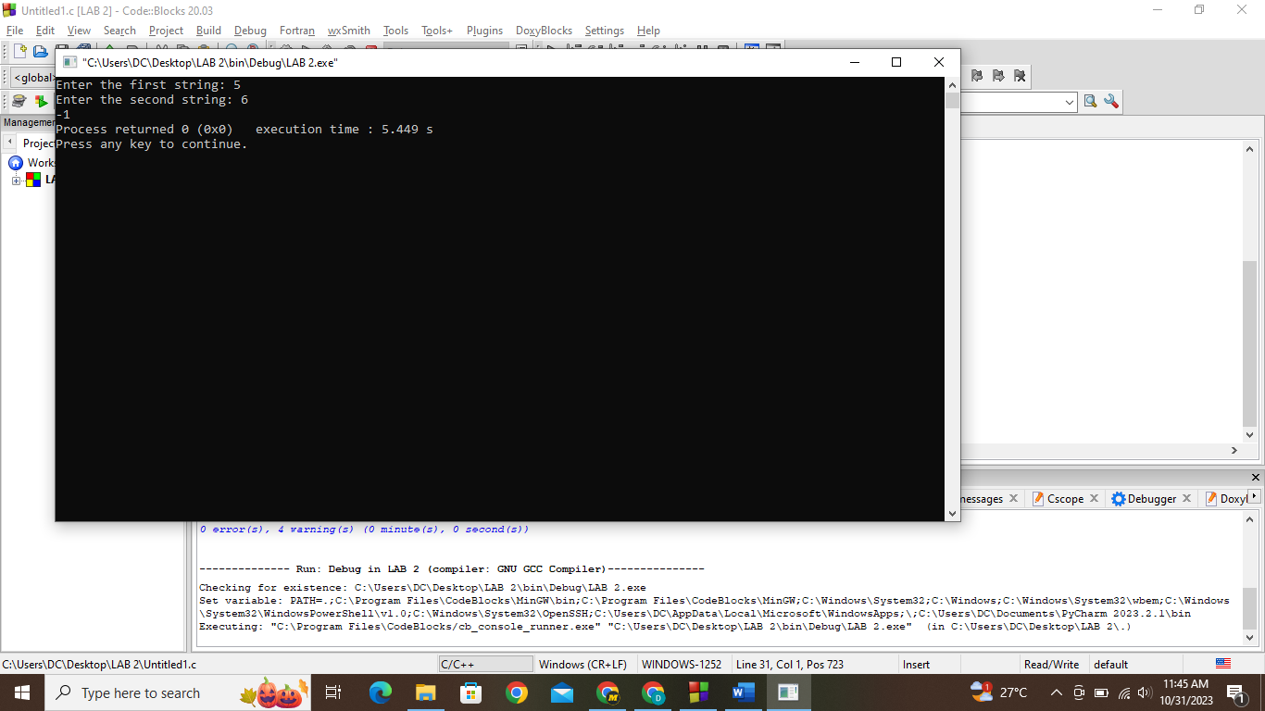

**Answer#4**

#include <stdio.h>

#include<ctype.h>

#include<string.

int main(){

int i=0;

char str[200],res[200];

printf("Enter the string: ");

scanf("%[^\n]s", &str);

printf("%s\n",str);

for(i=0;str[i]!='\0';i++)

{

if(isupper(str[i]))

res[i]=tolower(str[i]);

else if(islower(str[i]))

res[i]=toupper(str[i]);

else

res[i] = str[i];

}

printf("%s”);

return 0;

}

**Answer#5**

#include <stdio.h>

int main(){

int len, count;

printf("Enter the length of an array: ");

scanf("%d", &len);

int arr[len];

for(int i = 0; i<len; i++){

printf("Enter element#%d: ",i+1);

scanf("%d",&arr[i]);

}

printf("The unique elements in your array are:\n");

for(int i = 0; i<len; i++){

count = 0;

for(int j = 0; j<len; j++)

if(arr[i]==arr[j])

count++;

if(count==1)

printf("%d ", arr[i]);

}

return 0;

}

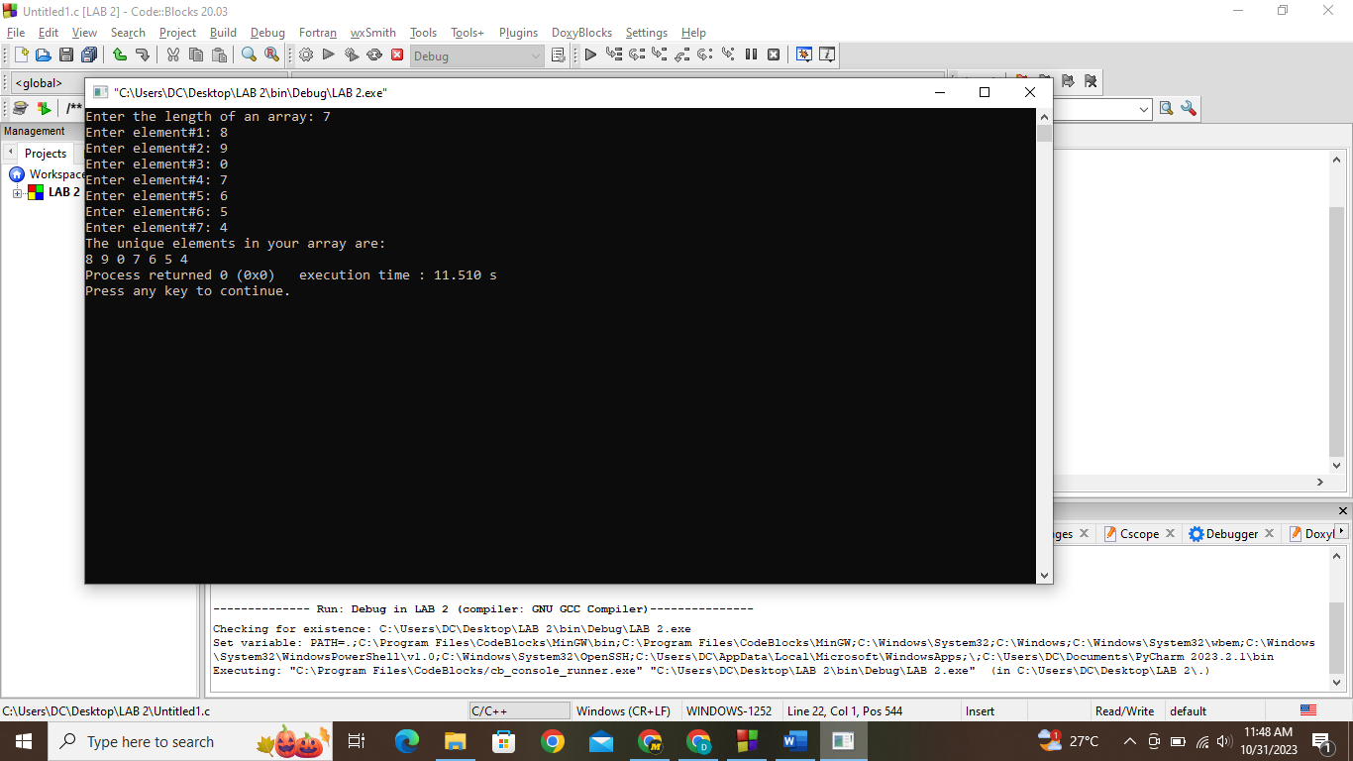

**Answer#6**

#include <stdio.h>

int main(){

struct Distance d1, d2;

printf("Enter the ft and inch of the first distance: ");

scanf("%d %d", &d1.ft, &d1.inch);

printf("Enter the ft and inch of the second distance: ");

scanf("%d %d", &d2.ft, &d2.inch);

printf("The total distance is: %d'%d\n", d1.ft+d2.ft, d1.inch+d2.inch);

return 0;

}